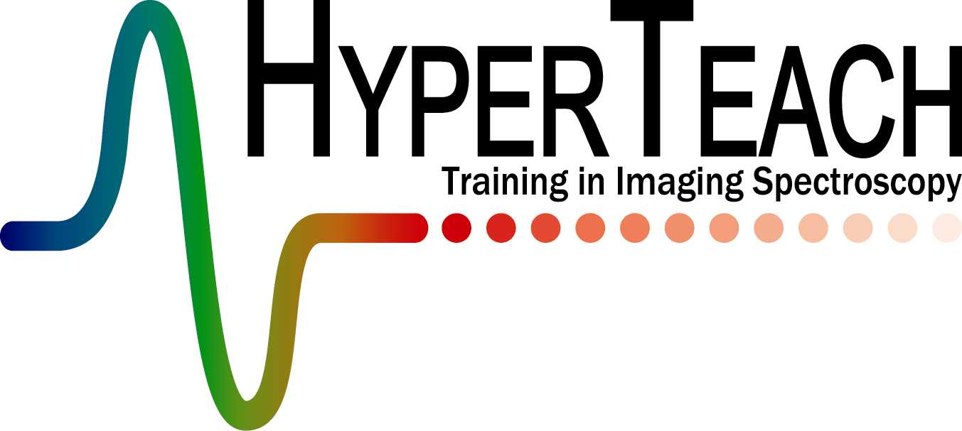
@SADC

HYPER@SADC: Registration form

(19-22 November, 2007)

To be returned before September 30th 2007 to: (Notification: October 8, 2007)

Sanette Kapp
SunSpace; Electron House; 15 Electron Street; Techno Park; Stellenbosch; 7600; South Africa
Fax: +27 (0) 21 880-1703 E-mail: sanette@sunspace.co.za

Title:
Name:
First Name:
Company/organization:
Dept.:
Position:
Mailing address:
……………………………..Postal code:
City:
Country:
Tel.:
Fax:
E-mail:
Please select options and provide details as required:

I will participate in the ‘HyperTeach@SADC’ training course on November 19-22, 2007 and choose the practical course on:
- Water & aquatic ecosystems
- Biodiversity

- I would like to attend the “Workshop and Strategy Session” on November 23, 2007

- I would like to present hyperspectral research during the “Workshop and Strategy” morning session (15 minute + 5 minute question session)
Hyperspectral Research Strategy and Workshop
(23 November, 2007)

If “yes” to previous question – the title of my research presentation is:

Motivation for participating in the training:

Education:

Research experience:

